Day 3 part II

BIVARIATEANALYSIS IN R -COVARIANCE, CORRELATION, CROSSTAB

Exercise: 8

Reference Status Gender TestNewOrFollowUp

1 KRXH Accepted Female Test1 New

2 KRPT Accepted Male Test1 New

3 FHRA Rejected Male Test2 New

4 CZKK Accepted Female Test3 New

5 CQTN Rejected Female Test1 New

6 PZXW Accepted Female Test4 Follow-up

7 SZRZ Rejected Male Test4 New

8 RMZE Rejected Female Test2 New

9 STNX Accepted Female Test3 New

10 TMDW Accepted Female Test1 New

i) Load the dataset and Create a data frame and name it as dataframe1

ii) Load the function for crosstab

Note: Perform status+gender

Gender

Status Female Male

Accepted 5 1

Rejected 2 2

Note: Reference+Status

Status

Reference Accepted Rejected

CQTN 0 1

CZKK 1 0

FHRA 0 1

KRPT 1 0

KRXH 1 0

PZXW 1 0

RMZE 0 1

STNX 1 0

SZRZ 0 1

TMDW 1 0

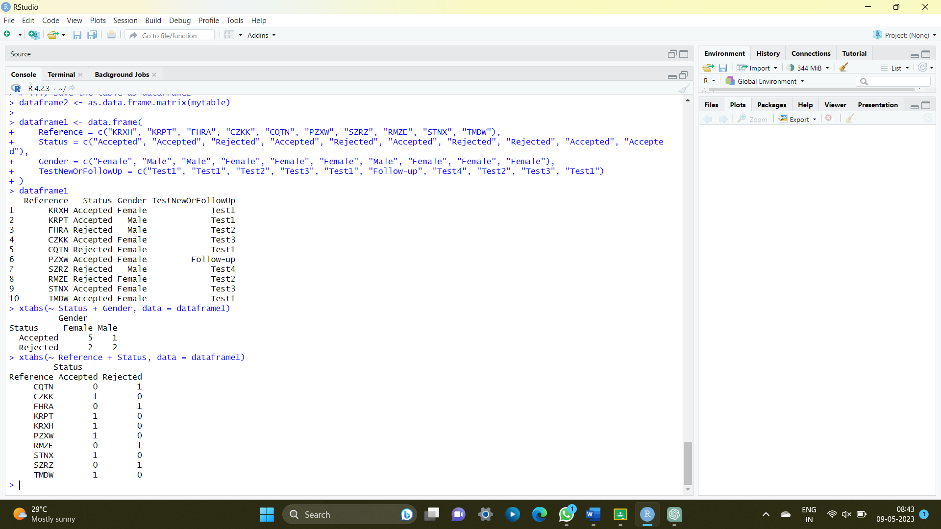

Exercise: 9

i) Use Two Categorical Variables and Discover the relationships within a

dataset

ii) Next, using the xtabs() function, apply two variables from “dataframe1 “, to

create a table delineating the relationship between the “Reference”

category, and the “Status” category.

iii) Save the file in the name of dataframe2

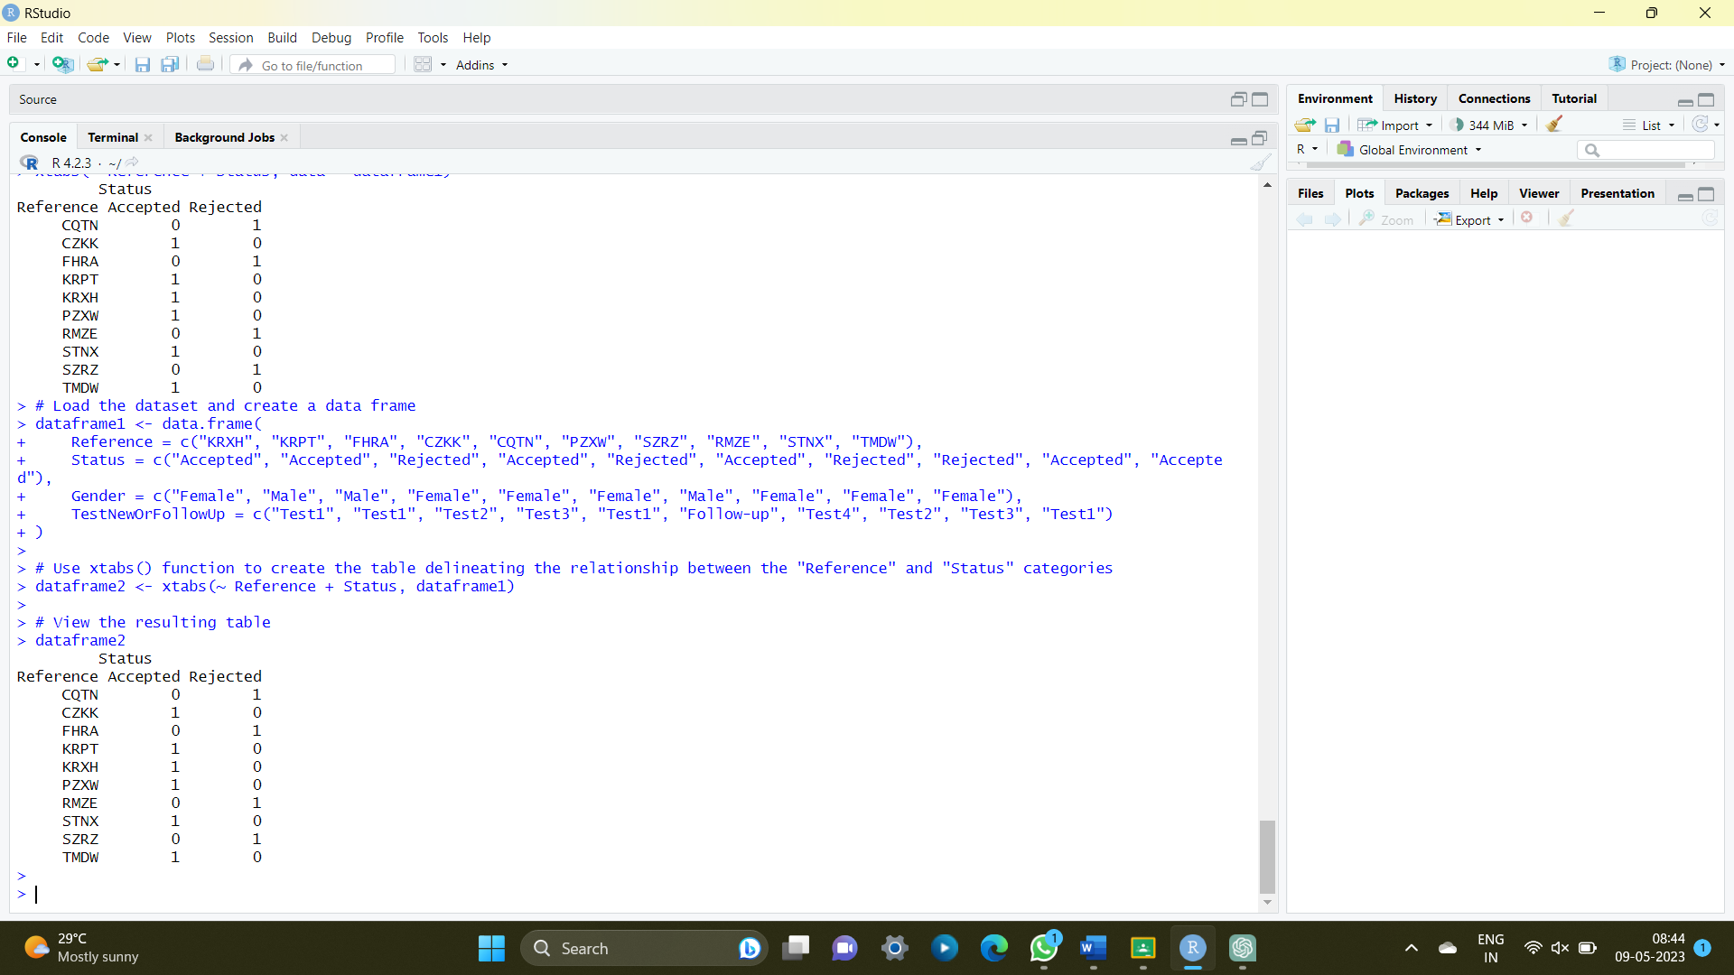

Exercise: 10

Use the same data frame using three Categorical Variables create a Multi-Dimensional Table

Apply three variables from “dataframe1” to create a Multi-Dimensional Cross-Tabulation of

“Status“, “Gender“, and “Test“.

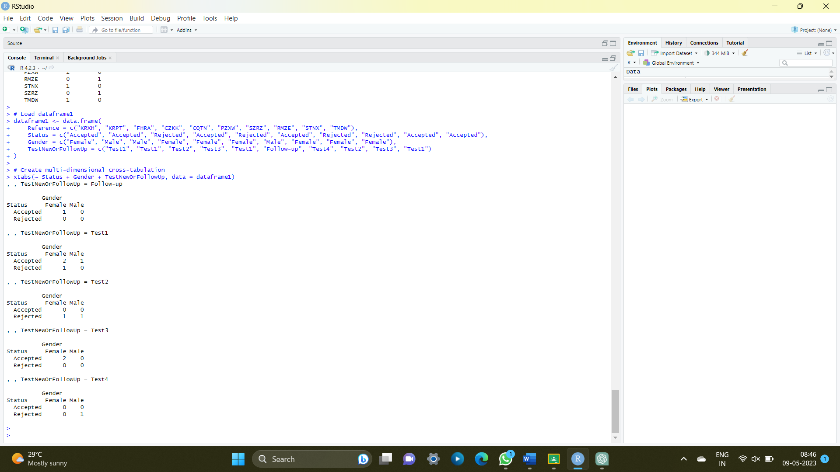

Exercise: 11

Row Percentages

The R package “tigerstats” is required for the next two exercises.

1) Create an xtabs() formula that cross-tabulates “Status“, and “Test“.

2) Enclose the xtabs() formula in the tigerstats function, “rowPerc()” to display row

percentages for “Status” by “Test“.

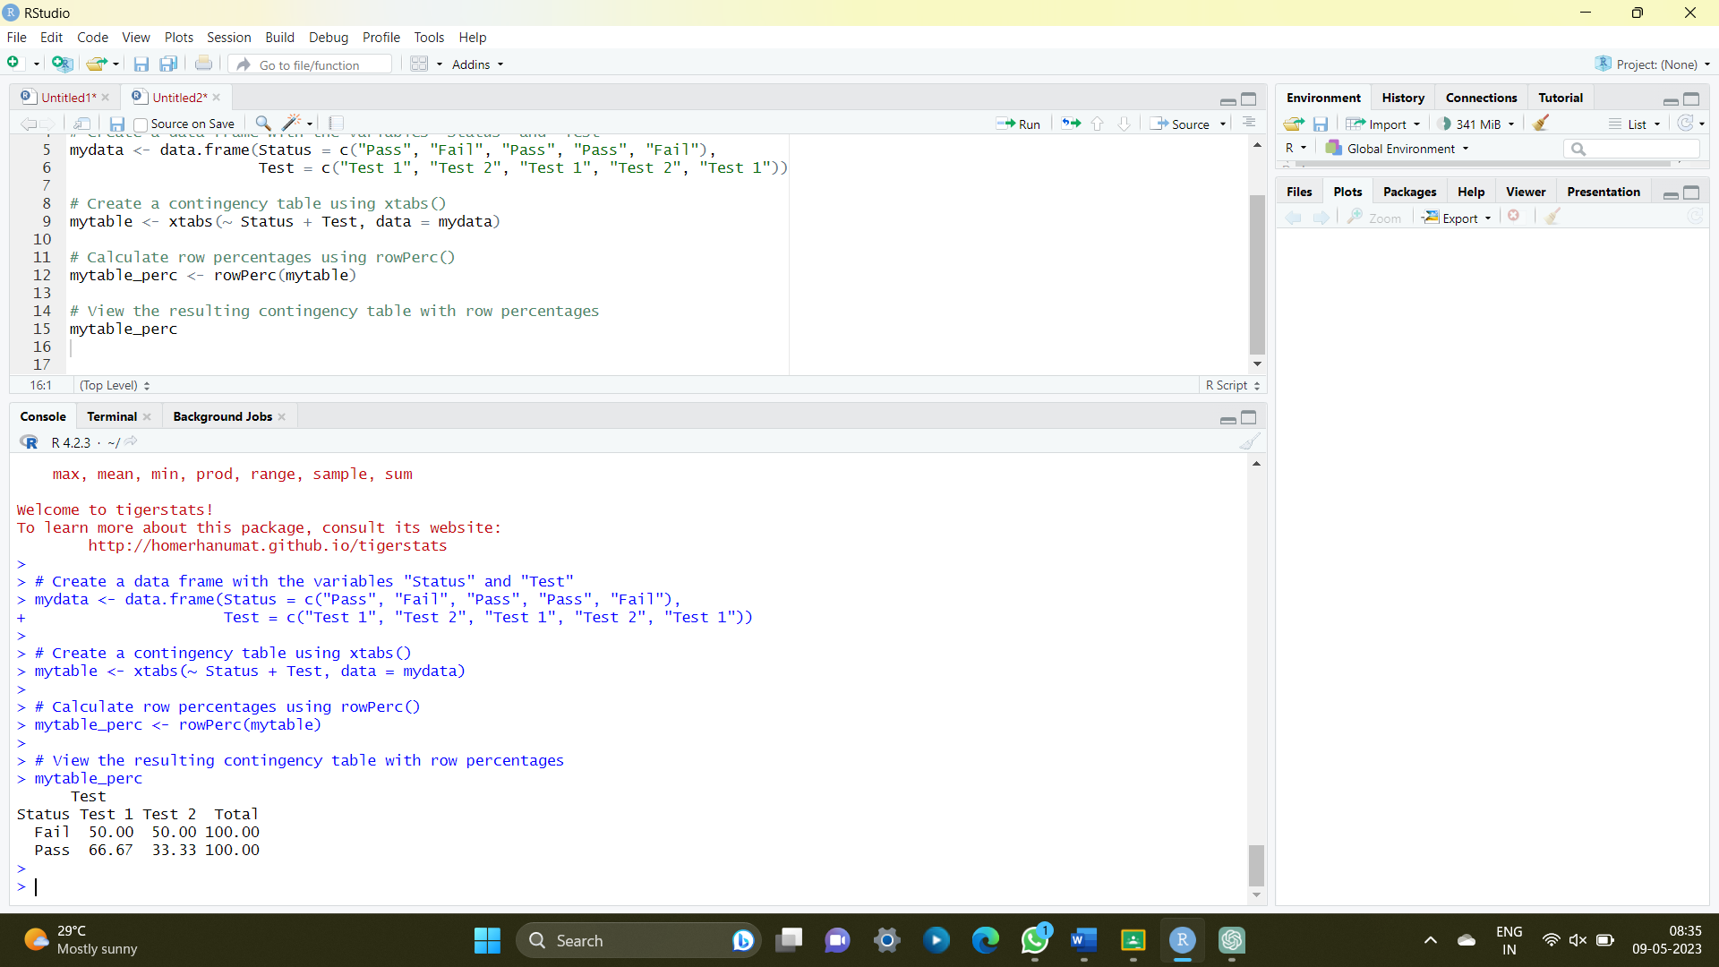

Exercise 12

Column Percentages

1) Create an xtabs() formula that cross-tabulates “Status“, and “Test“.

2) Enclose the xtabs() formula in the tigerstats function, “colPerc()” to display row

percentages for “Status” by “Test“.

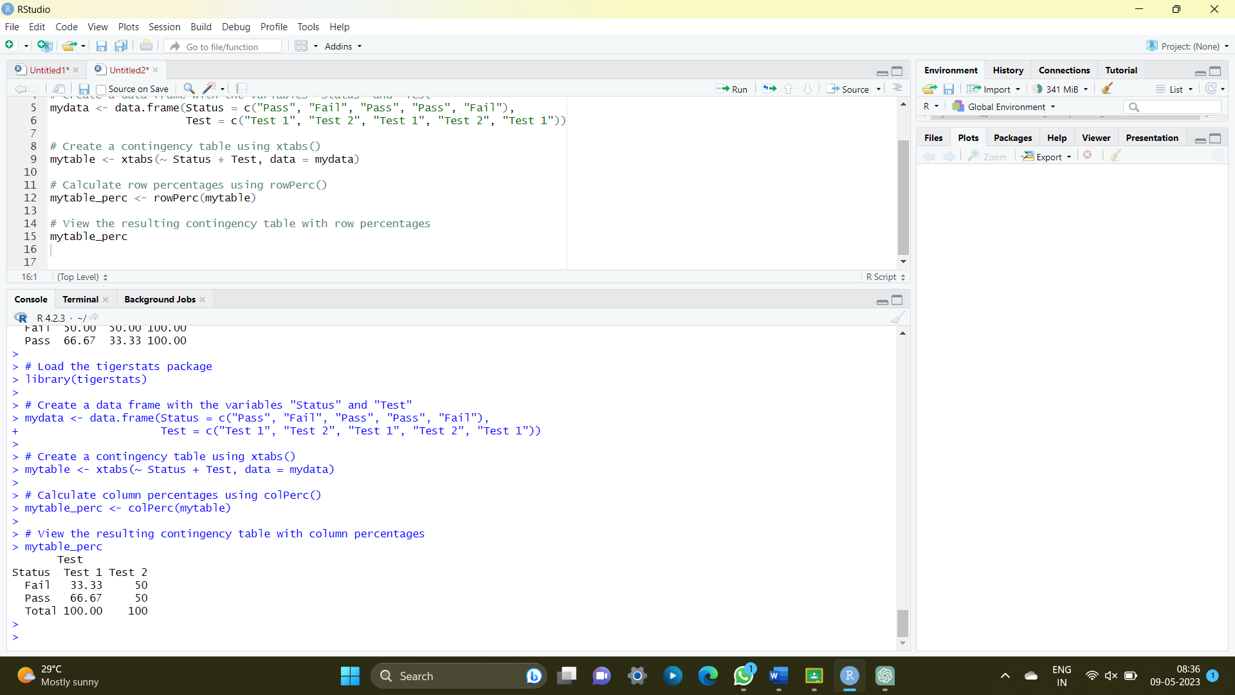

VISUALIZATION IN R

13. Write a program for creating a pie-chart in R using the input vector(21,62,10,53). Provide

labels for the chart as ‘London’, ‘New York’, ‘Singapore’, ‘Mumbai’. Add a title to the

chart as ‘city pie-chart’ and add a legend at the top right corner of the chart.

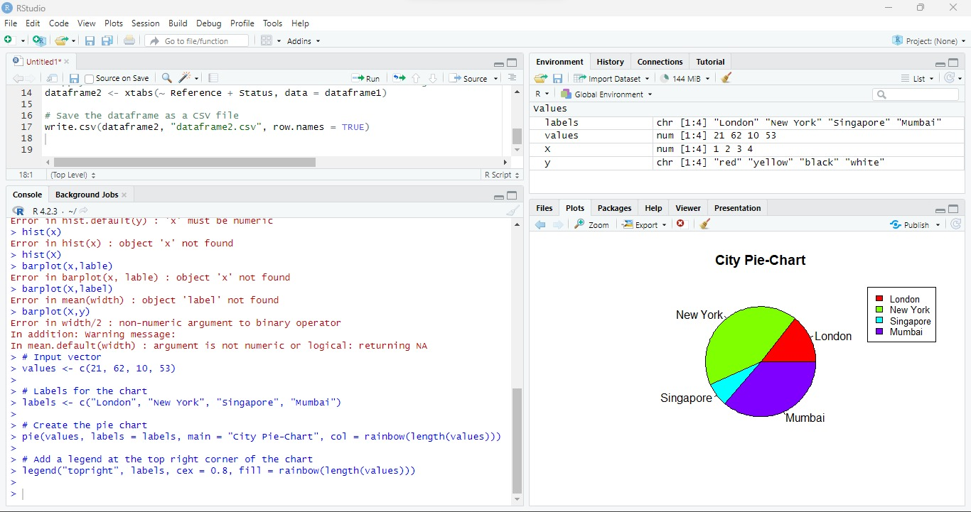

14. Create a 3D Pie Chart for the dataset “political Knowledge” with suitable labels,colours

and a legend at the top right corner of the chart.

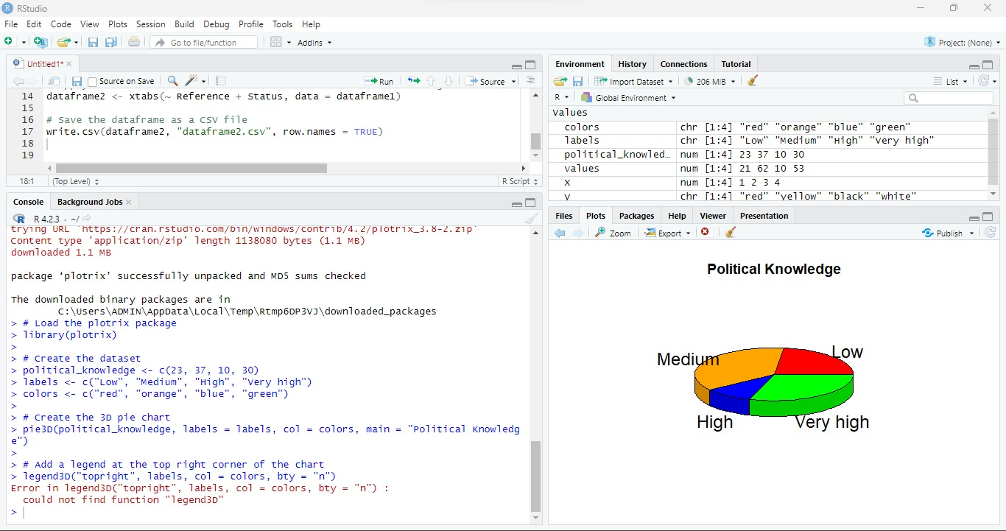

15. Write a program for creating a bar chart using the vectors H=c(7,12,28,3,41) and

M=c(“mar”, “apr”, “may”, “jun”, “jul”). Add a title to the chart as “Revenue chart”.

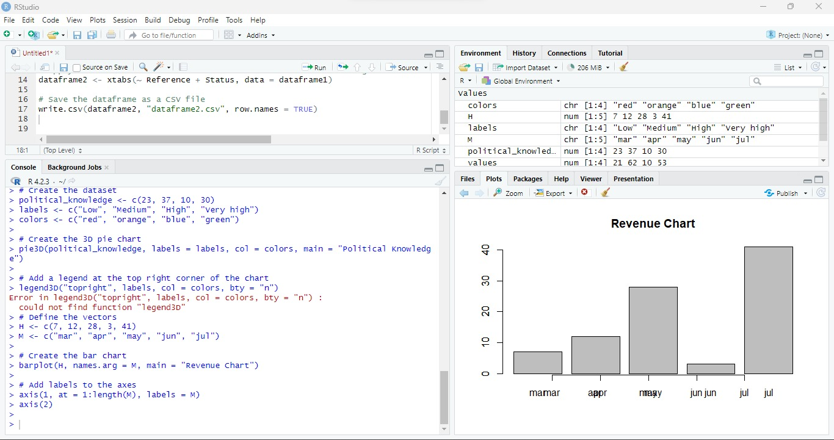

16. Make a histogram for the “AirPassengers“dataset, start at 100 on the x-axis, and from

values 200 to 700, make the bins 200 wide

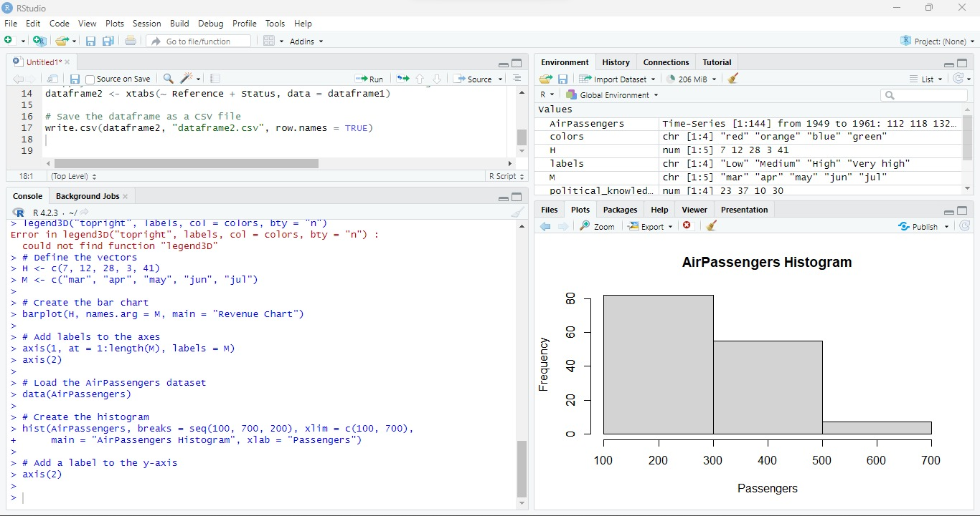

17. Create a Boxplot graph for the relation between &quot;mpg&quot;(miles per galloon) and

&quot;cyl&quot;(number of Cylinders) for the dataset &quot;mtcars&quot; available in R Environment.

